**DIWALI SALES PROJECT REPORT**

(Project Semester January-May 2024)

***DIWALI SALES***

Submitted by

Madarapu Purna Sai

Registration No. 12110664

Programme and Section: B.Tech CSE and K21DP

Course Code: INTB233

Under the Guidance of

**Maneet Kaur 15709**

**Assistant Professor**

**Discipline of CSE/IT**

**Lovely School of Computer Science and Engineering**

**Lovely Professional University, Phagwara**



**CERTIFICATE**

This is to certify that Madarapu Purna Sai bearing Registration no. 12110664 has completed INTB233 project titled, **“Diwali Sales”** under my guidance and supervision. To the best of my knowledge, the present work is the result of his/her original development, effort and study.

**Maneet Kaur**

**Assistant Professor**

**School of Computer Science and Engineering**

Lovely Professional University

Phagwara, Punjab.

Date:

**DECLARATION**

I, Madarapu Purna Sai, student of CSE under CSE/IT Discipline at, Lovely Professional University, Punjab, hereby declare that all the information furnished in this project report is based on my own intensive work and is genuine.

M.Purna Sai

Date: 18-04-2024 Signature

Registration No. 12110664 Name of Student: Madarapu Purna Sai

**Acknowledgment**

The satisfaction that accompanies the successful completion of this project would be in complete without the mention of the people who made it possible, without whose constant guidance and encouragement would have made efforts go in vain. I consider myself privileged to express gratitude and respect towards all those who guided us through the completion of this project.

I convey thanks to my project guide Maneet Kaur of the Computer Science and Engineering Department for providing encouragement, constant support, and guidance which was of great help in completing this project successfully.

Last but not least, we wish to thank our parents for financing our studies in this college as well as for constantly encouraging us to learn engineering. Their personal sacrifice in providing this opportunity to learn engineering is gratefully acknowledged.

Table of Contents

- Cover page 1

- Certificate 2

- Declaration 3

- Acknowledgement 4

- Table of Contents 5

1. Introduction 6
2. Scope of the Analysis 7
3. Drawbacks or limitations of the existing system 8
4. Source of dataset 9-10
5. ETL process 10
6. Analysis of dataset 11-17
   1. Adidas in USA 11-12
   2. Units Sold Region-wise 12-13
   3. Products Monthly Sales 13-14
   4. Top 5 Retail Sellers of Adidas Products in the USA 15-16
   5. Sales Method 16-17
7. List of Analysis with results 18-22
8. Future Scope 23-24
9. References 25

**1. Introduction**

Introducing the Diwali sales dashboard, I delve into the sales performance during the festive season of Diwali, shedding light on key trends, customer behavior, and the effectiveness of marketing strategies. Diwali, also known as the Festival of Lights, holds immense cultural and economic significance in India, often marking a period of heightened consumer activity across various industries.Drawing from a comprehensive dataset collected from I leverage the power of Tableau to analyze and visualize this data, uncovering valuable insights to inform strategic decision-making. Our audience includes stakeholders, executives, and marketing teams keen on understanding the dynamics of Diwali sales and maximizing opportunities in future festive seasons.

Moreover, Tableau's versatility allows for seamless integration with external data sources, enabling stakeholders to augment Diwali sales data with market research, competitor analysis, and macroeconomic indicators for a holistic view of the different sales landscape. With the ability to customize views, filter data, and generate on-the-fly visualizations, Tableau empowers users to tailor their analysis to specific business objectives and audience preferences, fostering collaboration and driving data-driven decision-making across the organization.In essence, the Adidas sales dashboard powered by Tableau transcends traditional reporting paradigms, offering a dynamic and interactive platform for exploring, analyzing, and deriving insights from sales data. Whether you're a marketing executive seeking to optimize advertising spend, a sales manager aiming to identify untapped market opportunities, or a C-suite executive tasked with charting the company's strategic direction, this Tableau-powered dashboard is your indispensable companion in navigating the complexities of the sportswear industry and unlocking the full potential of Diwali sales performance.

**2. Scope of Analysis:**

The scope of analysis for the Adidas sales dashboard created using Tableau encompasses a multifaceted exploration of sales dynamics within the Different States of India. Firstly, the dashboard delves into the geographical distribution of sales by identifying the states driving Diwali product purchases, offering insights into regional preferences and market penetration strategies. Secondly, it analyzes orders received from different zones-wise, facilitating the identification of trends, disparities, and growth opportunities across different areas of the country. Thirdly, the dashboard tracks Amount gained from sales across different different states in India, enabling sellers to discern seasonality, trends, and the impact of marketing initiatives on consumer behavior. Additionally, it highlights the top sales on different product categories during Diwali Sale, shedding light on distribution channels, market share, and competitive dynamics. Lastly, the analysis includes an examination of Orders from different Zones and amount gained from different product category, whether through Food, Footwear, or other Electronic Gadgets, providing insights into consumer behavior and preferences in Ordering different products. Through this comprehensive scope of analysis, stakeholders gain a nuanced understanding of Diwali sales performance in the different states, empowering them to make informed decisions and drive business success.

**3. Drawbacks or limitations of the existing system**

The existing system for analyzing Diwali sales data in the Different states of India, while benefiting from Tableau's visualization capabilities, encounters several notable limitations that compromise its overall efficiency and efficacy. One significant drawback lies in the reliance on manual data processing methods, which are prone to human error and can result in inaccuracies within the analysis. Moreover, the system's scalability may be constrained, particularly in managing larger datasets or accommodating the evolving complexities of Diwali sales over time. Additionally, if the system predominantly offers static reports or pre-defined dashboards, it may hinder users' ability to conduct dynamic and nuanced analyses, limiting their capacity to uncover actionable insights and respond promptly to market changes.

Furthermore, data silos and integration challenges may impede the system's ability to access and consolidate information from diverse sources, leading to fragmented insights and inhibiting a comprehensive understanding of Adidas's sales performance. Moreover, while Tableau provides powerful visualization tools, if the existing system lacks interactivity or user-friendly features, it may fail to fully leverage Tableau's potential to engage stakeholders and facilitate data-driven decision-making. Without intuitive interfaces and interactive functionalities, stakeholders may encounter difficulties in exploring the data thoroughly and extracting meaningful insights to inform strategic actions.

Addressing these limitations is paramount to optimizing the Diwali sales analysis system from different states of India. By implementing automated data processing solutions, enhancing scalability to accommodate growing datasets, and fostering seamless integration with external sources, the system can overcome current constraints and unlock its full analytical potential. Moreover, by prioritizing interactive visualization features and user-friendly interfaces within Tableau, stakeholders can enhance their ability to explore data dynamically, derive actionable insights, and drive informed decision-making processes that propel Diwali products seller’s success in the competitive market of India.

**4. Source of DataSet:**

The dataset is taken from Kaggle. Kaggle is a platform that hosts a variety of datasets from different domains such as healthcare, finance, sports, and more. The datasets on Kaggle are contributed by users and organizations from all over the world.

To access datasets on Kaggle, you first need to create an account on the platform. Once you have an account, you can search for datasets using the search bar on the Kaggle homepage or browse through the datasets by category.

About: An Diwali Products sales dataset is a collection of data that includes information on the sales of Different diwali products from different zones of India. This type of dataset may include details such as the number of Products sold, the total sales Amount, the location of the Orders, the type of product sold, and any other relevant information.

Diwali sales data can be useful for a variety of purposes, such as analyzing sales trends, identifying successful products or marketing campaigns, and developing strategies for future sales. It can also be used to compare, or to analyze the effectiveness of different marketing or sales channels.

There are a variety of sources that could potentially provide an Adidas sales dataset, including Adidas itself, market research firms, government agencies, or other organizations that track sales data. The specific data points included in an Diwali sales dataset may vary depending on the source and the purpose for which it is being used.

Here are the details of my chosen data set.

* Name: Diwali Sales Dataset
* Link: <https://www.kaggle.com/datasets/bishtudas/diwali-sales-dataset>
* Format: CSV
* No. of data sets: 1
* Number of Rows: 11252
* Number of columns: 13
* Size: 1.1 MB
* Date Fields:
  1. User_ID
  2. Cust_name
  3. Product_Id
  4. Gender
  5. Age Group
  6. Age
  7. Marital_Status
  8. State
  9. Zone
  10. Occupation
  11. Product_Category
  12. Orders
  13. Amount

**5. ETL process**

Extracted the data set from the Kaggle which contains the date of sales During Diwali across various States in India.

Transformed the data by removing the two unknown blanked columns.

Loaded the dataset into the Tableau.

Created Diwali Sales dashboard using the Tableau.

**6. Analysis of DataSet**

6.1. Orders from Different States of India:

1. Introduction: This provides a visual representation of the geographic distribution of Diwali product sales across different states in the India. By analyzing sales data at the state level, stakeholders can gain insights into regional preferences, market penetration, and consumer behavior. Through interactive maps, users can easily identify which states are driving the highest sales volumes and explore potential opportunities for market expansion or targeted marketing campaigns. Additionally, trends in sales performance across different regions can help stakeholders understand variations in demand and tailor their strategies accordingly.
2. General Description: The Diwali Sales Analysis dashboard’s “Orders and State” category gives you a 360-degree view of your country’s geographic sales distribution. Visualize sales data at a state level, and you’ll be able to get a better understanding of regional preferences and strategies for market penetration. This analysis allows you to see which states are driving the highest volume of orders from diff states, product purchases, and highlights key strength and opportunity areas. With this information, you can tailor your marketing campaigns, optimize your resource allocation, and optimize your distribution strategies to drive sales and take advantage of emerging trends in particular geographic regions.
3. Analysis Result:

A Map that shows you where orders are being sold or used in different states of India. This Map will show you the states in India where the number of orders and the amount of sales are being made from different states. This map visualization will show you the geographic distribution of the Diwali sales. You can see the regions with the most and least sales volumes. It will show you the market penetration and the consumer preferences in different states. By looking at the sales data from a spatial perspective, you can see the potential growth opportunities in the regions that are not doing well and how you can use your resources to make the most of strong markets. The map can also show you the areas where you need to focus your marketing or distribution strategies to improve your sales performance.

1. Visualization:

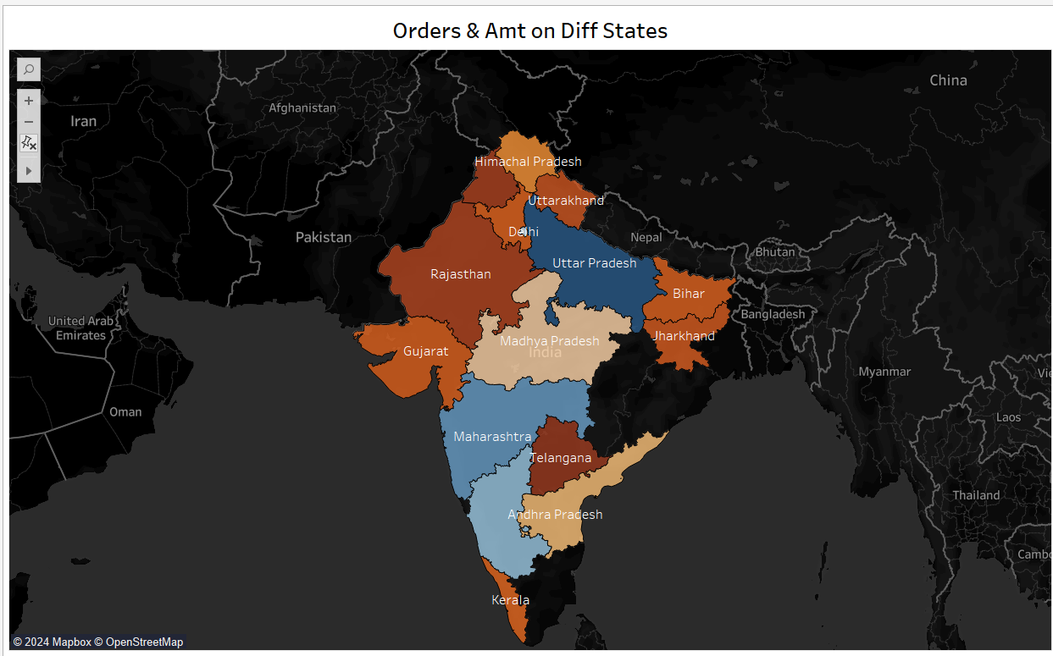

6.2. Product Category

1. Introduction: It is important to understand the regional differences in the number of units sold. This will help you to identify the areas of strength and opportunities in the Indian market.By analysing the sales data across the different regions, stakeholders will be able to identify trends, differences, and growth opportunities. This will help them to allocate resources more efficiently and to target marketing efforts in particular geographic areas.
2. General Description: The Diwali Sales Dashboard “Product Category” section provides an in-depth analysis of sales performance by region within Different states of india. By breaking down sales data by geographic region, stakeholders can gain insights into the variation in consumer demand as well as market trends.By analyzing regional sales data, stakeholders can gain a better understanding of which areas are driving the highest sales volume and which areas are driving growth. By analyzing regional trends, disparities and growth potential, stakeholders can adjust their marketing, distribution and inventory strategies to optimise sales performance and take advantage of regional market dynamics.
3. Analysis results

Use highlighted tables to display the amount of products sold. This shows the number of products sold and the amount gained.Highlighted tables charts show the amount gained across different products within the state. This makes it easier to compare and analyze trends over time.Visualizations show regional trends, differences, and growth potential. By analyzing changes in sales volumes across different areas, stakeholders can adjust their marketing, inventory, and distribution strategies to meet particular regional needs.In the highlighted tables format, stakeholders can see the impact of each region on overall sales performance. This helps them to allocate resources and make strategic decisions.

1. Visualization

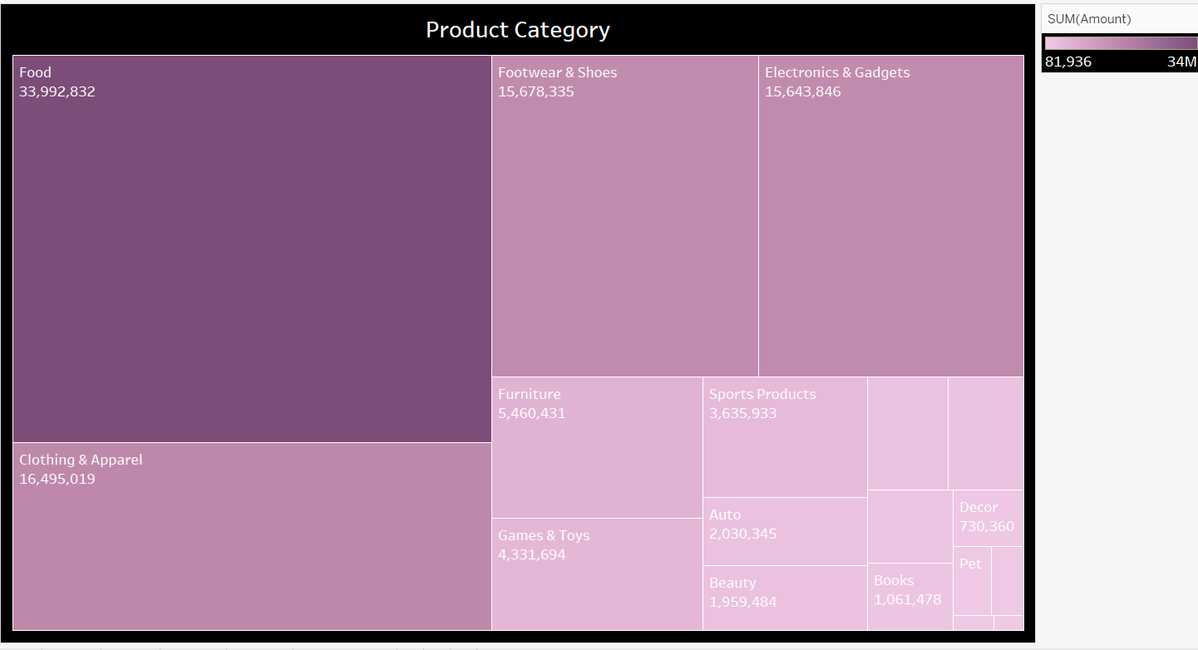

6.3 Age Group vs Amount gained

1. Introduction: By tracking the amount collected from different age groups, stakeholders can see seasonal patterns, trends, and trends in consumer behavior. Visualize age groups data on a monthly basis, allowing stakeholders to identify peak periods, measure the impact of marketing and promotional campaigns, and make informed inventory management and product decisions.
2. General Description: Age group vs amount gained The Diwali Sales Dashboard provides a monthly overview of sales performance across the states. Through this analysis, stakeholders can monitor trends, seasonality and variations in consumer demand for Diwali products across the year. View Diwali sales data in real-time Visualize monthly sales data across the states Identify peak periods Analyze impact of marketing campaigns/promotions Decide how to manage inventory and product development Understand consumer preferences over time Adapt strategies to maximize sales Drive business growth effectively
3. Analysis results

I used Pie Chat to represent age group and money gained. This pie chat shows age groups and money gained from different age groups. Pie charts provide a detailed view of Diwali sales data across the states. They show seasonal trends, peak and trough sales in Diwali products. These visualizations allow stakeholders to see patterns and change in consumer demand across the year. This makes it easier for them to make informed decisions regarding stock management, marketing campaigns and product launches.By analyzing monthly sales data in a discrete manner, stakeholders can identify factors that cause sales performance to fluctuate, such as seasonal promotion, product launches or external market influences. They can adjust strategies accordingly to maximize sales and revenue.

1. Visualization

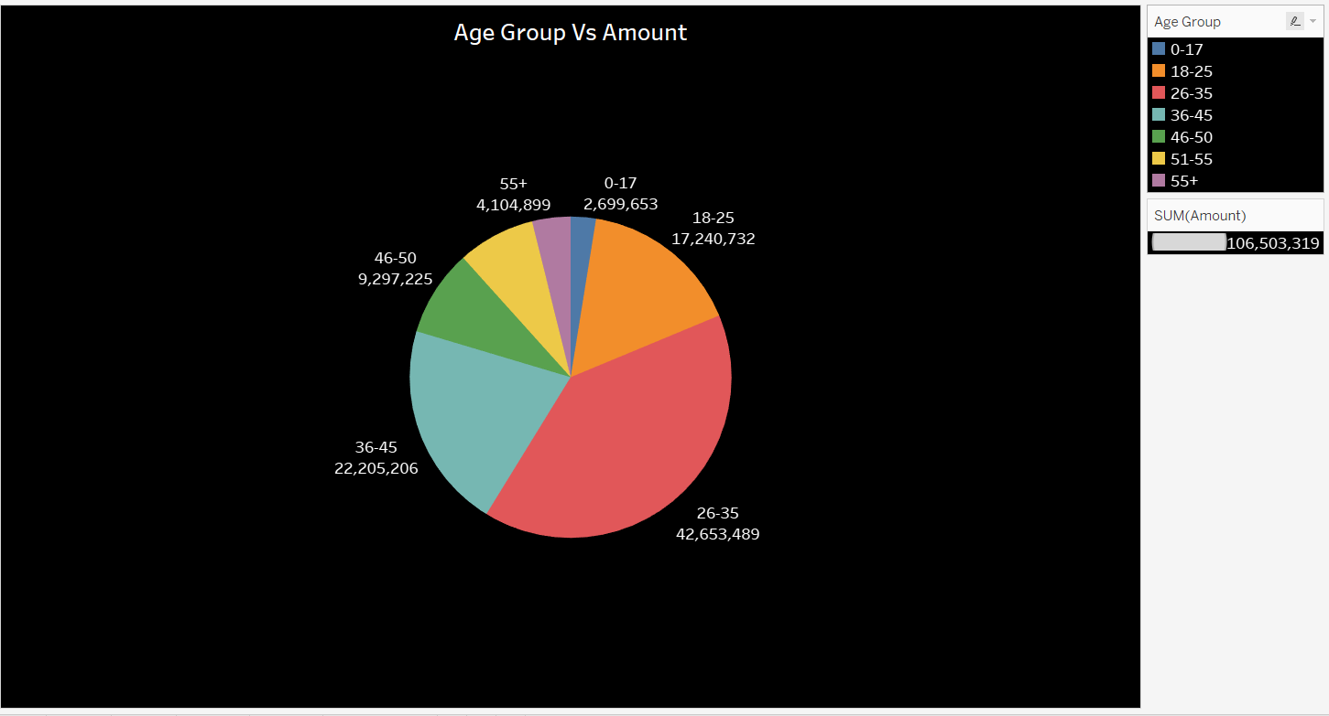

6.4. Orders on Different Zones

1. Introduction: The top Diwali Zones provide insight into distribution channels and market share, as well as competitive dynamics. Ranking Zones on the basis of sales volumes or revenue allows stakeholders to evaluate the success of distribution relationships, identify potential partners for co-promotion, and gain insights into consumer preferences and buying behaviour.
2. General Description : In the “ Orders on different Zones” section of your Diwali Sales dashboard, you’ll find the top Zones according to sales volumes or revenue.Once you’ve identified the top Zones for Diwali, you’re in a better position to understand which distribution channels are driving the highest Diwali volumes of sales within your India market.You’ll be able to gain insights into market share and competitive dynamics, as well as the effectiveness of your distribution partnerships.By knowing which retailers are generating sales, you can optimize your distribution strategies, strengthen your partnerships with key partners and take advantage of growth opportunities in the retail landscape.
3. Analysis results

A Bar graph is used to represent the top Zone sales. This graph shows the total sale of the Zones in states for Diwali. The bar graph showing the top zones for Diwali products gives an idea of the market share, the dynamics of competition, and the distribution effectiveness of the top retailers. It compares the sales performance of the top retailers in the market, identifies the top players in the market, and compares the relative strengths and weaknesses of each retailer. By analysing the sales data of the top retailers, stakeholders can assess the effectiveness of the distribution partnerships, find potential partners for the co-marketing efforts, and gain a better understanding of consumer buying behavior in different retail environments.

1. Visualization

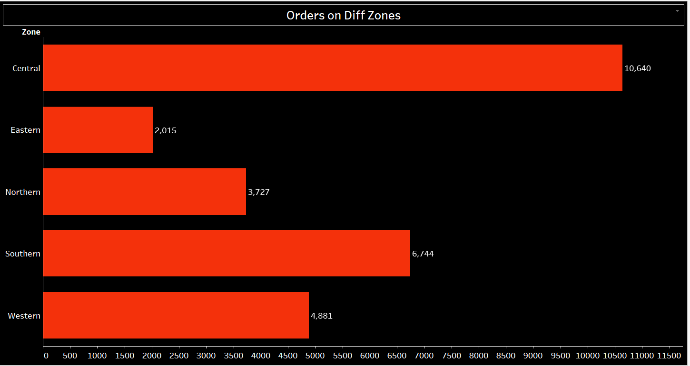

6.5. Orders on Different Category

1. Introduction: It is important to understand the orders on different products that Diwali Diwali Products are selling in different states, whether it is Electronics or Clothing. By analysing sales data by methods, stakeholders can see consumer trends, evaluate the performance of various sales channels and adjust their strategy to meet changing customer needs and market dynamics.
2. General Description: It is important to understand the orders on different products that Diwali Diwali Products are selling in different states, whether it is Electronics or Clothing. By analysing sales data by methods, stakeholders can see consumer trends, evaluate the performance of various sales channels and adjust their strategy to meet changing customer needs and market dynamics.
3. Analysis results

Packed Bubbles are used to represent orders on different categories. This shows total sales from different methods. For example, is Electronics or clothing etc.The packed bubble chart shows how sales are distributed across different methods. It provides insights on consumer buying patterns and preferences.By analyzing sales data based on different methods, stakeholders can see trends in consumer buying behavior, evaluate the performance of various sales channels and adjust their approach to keep up with changing customer preferences and changing market dynamics.In addition, packed bubble format makes it easy for stakeholders to compare sales volumes and distribution efficiency across different sales methods. This helps in making strategic decisions on how to allocate resources and optimize channels.

1. Visualization

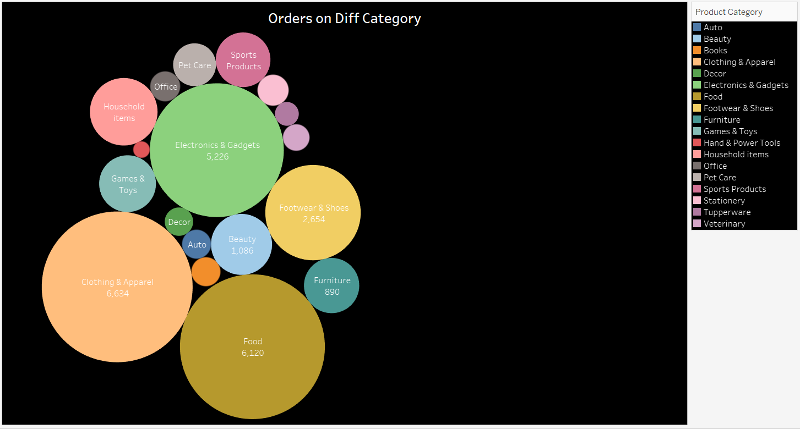

7. List of Analysis with Results

States Selling Diwali Products in the India (Map Visualization): The map visualization showcases the geographic distribution of Diwali product sales, allowing stakeholders to pinpoint regions with the highest and lowest sales volumes. It enables a visual understanding of market penetration and consumer preferences across different states. By analyzing sales data spatially, stakeholders can identify potential growth opportunities in underperforming regions and allocate resources effectively to capitalize on strong markets. Moreover, the map can highlight areas where targeted marketing efforts or distribution strategies may be needed to further enhance sales performance.

Product Category: Highlighted table charts provide a detailed breakdown of products and amount gained across various products, facilitating comparisons and trend analysis over time. These visualizations allow stakeholders to identify regional trends, disparities, and growth opportunities. By examining changes in sales volume across different regions, stakeholders can tailor their marketing strategies, inventory management, and distribution efforts to meet specific regional demands effectively. Moreover, the stacked format enables stakeholders to discern the contribution of each region to overall sales performance, guiding resource allocation and strategic decision-making.

Age Group vs Amount gained (Pie Charts ): I used Pie Chat to represent age group and money gained. This pie chat shows age groups and money gained from different age groups. Pie charts provide a detailed view of Diwali sales data across the states. They show seasonal trends, peak and trough sales in Diwali products. These visualizations allow stakeholders to see patterns and change in consumer demand across the year. This makes it easier for them to make informed decisions regarding stock management, marketing campaigns and product launches.By analyzing monthly sales data in a discrete manner, stakeholders can identify factors that cause sales performance to fluctuate, such as seasonal promotion, product launches or external market influences. They can adjust strategies accordingly to maximize sales and revenue.

Orders on Different Zones:

A Bar graph is used to represent the top Zone sales. This graph shows the total sale of the Zones in states for Diwali. The bar graph showing the top zones for Diwali products gives an idea of the market share, the dynamics of competition, and the distribution effectiveness of the top retailers. It compares the sales performance of the top retailers in the market, identifies the top players in the market, and compares the relative strengths and weaknesses of each retailer. By analysing the sales data of the top retailers, stakeholders can assess the effectiveness of the distribution partnerships, find potential partners for the co-marketing efforts, and gain a better understanding of consumer buying behavior in different retail environments.

Dashboard Picture:

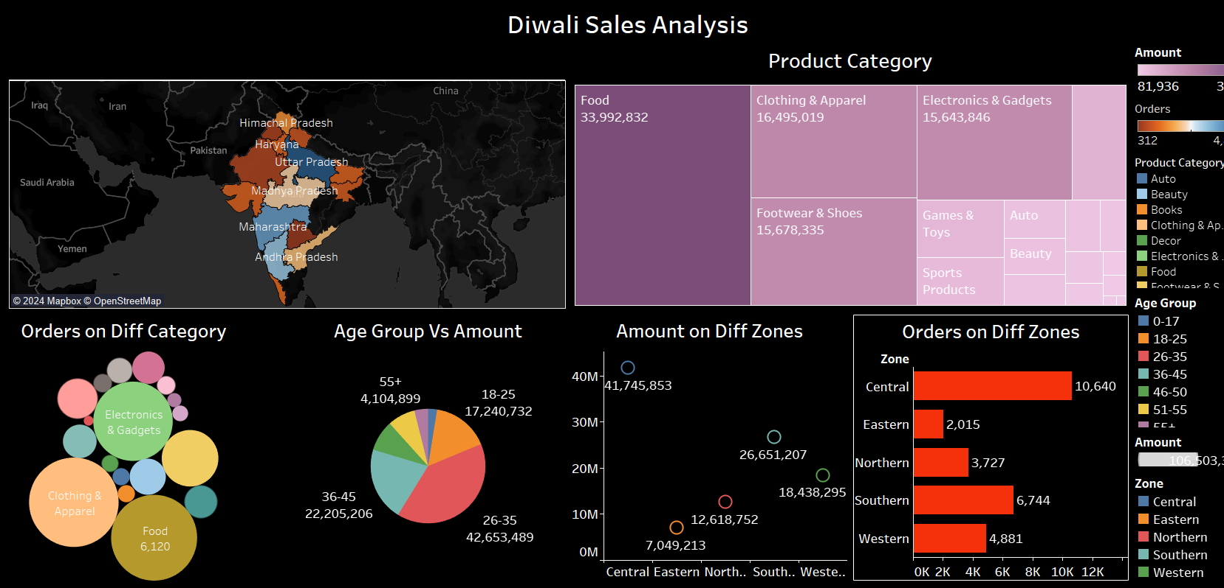

Individual Sheets:











**8. Future Scope**

Looking ahead, there's a wealth of opportunities to expand and enhance the Diwali sales dashboard, leveraging Tableau's robust capabilities to deliver even greater insights and value. Firstly, incorporating predictive analytics could empower stakeholders to forecast future sales trends based on historical data, market dynamics, and external factors such as economic indicators and consumer sentiment. By integrating machine learning algorithms, the dashboard could dynamically predict sales volumes, identify emerging market trends, and recommend targeted strategies to capitalize on opportunities and mitigate risks.

Moreover, expanding the geographical scope beyond the India could provide a broader perspective on Diwali sales performance, enabling stakeholders to compare regional trends, assess market saturation, and identify untapped markets for expansion. By integrating external data sources such as demographic information, social media trends, and competitor analysis, the dashboard could offer a comprehensive view of the competitive landscape and consumer preferences, empowering stakeholders to refine their marketing strategies, product offerings, and distribution channels effectively.

Furthermore, incorporating real-time data feeds could enable stakeholders to monitor sales performance and market trends in real-time, facilitating agile decision-making and rapid response to changing market conditions. By integrating Tableau with other analytics tools and platforms, such as customer relationship management systems and supply chain management software, the dashboard could offer end-to-end visibility into the sales process, from customer acquisition to product delivery, enabling stakeholders to optimize operations and enhance customer satisfaction.

Additionally, enhancing the interactivity and user experience of the dashboard could further engage stakeholders and facilitate deeper exploration of the data. By incorporating drill-down capabilities, filters, and dynamic visualizations, users could interactively explore sales data, uncover insights and answer ad hoc questions with ease. Moreover, incorporating storytelling features could enable stakeholders to communicate key findings and actionable insights effectively, fostering collaboration and driving alignment across the organization.

The future scope for the Adidas sales dashboard is vast and exciting, encompassing predictive analytics, global expansion, real-time monitoring, and enhanced interactivity. By leveraging Tableau's powerful capabilities and integrating diverse data sources, the dashboard can evolve into a strategic tool that empowers stakeholders to make informed decisions, drive business growth, and stay ahead in the dynamic and competitive landscape of the sportswear industry.

LinkedIn Post :

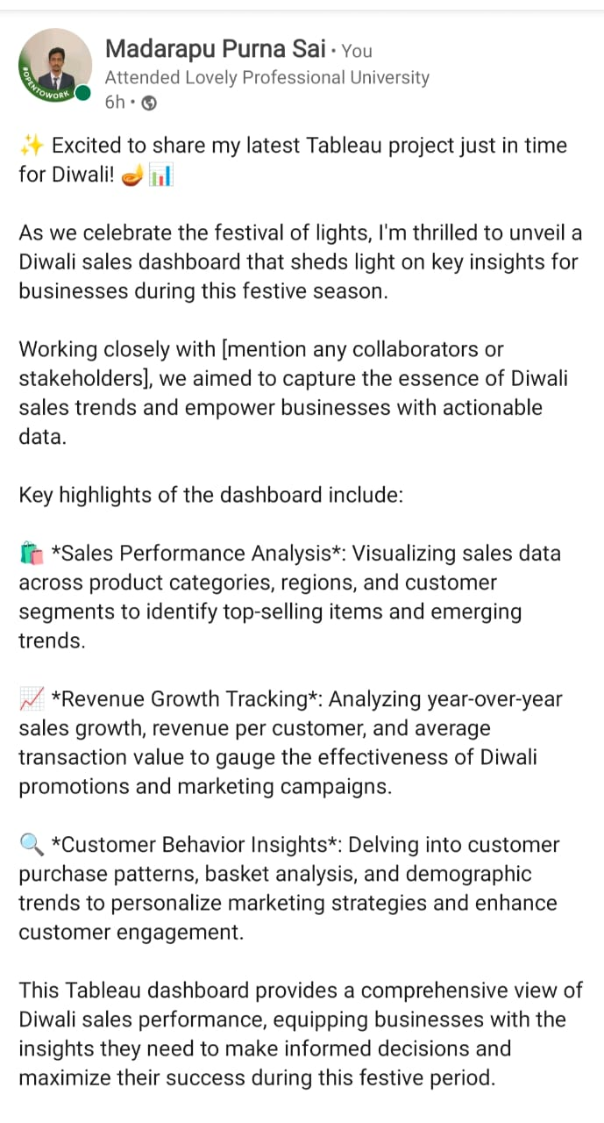

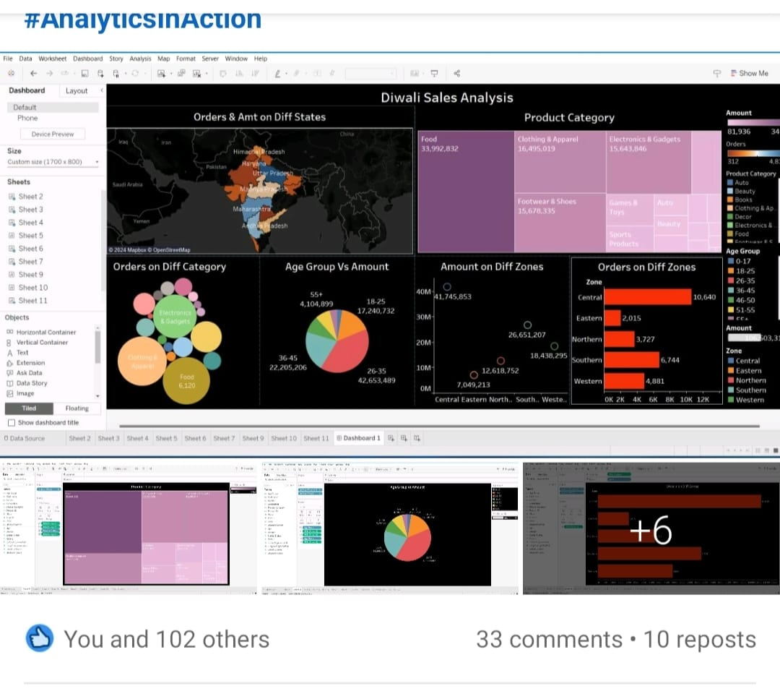

**9. References**

[www.kaggle.com](http://www.kaggle.com)

[www.youtube.com](http://www.youtube.com)

[www.google.com](http://www.google.com)